**MANİSA CELAL BAYAR UNIVERSITY**

**CSE 4103/CSE 4123**

**SOFTWARE ENGINEERING**

**FALL 2020**

**PROJECT : 3 Customized Visual Bookshelf from Gutenberg Project**

**Prepared by**

Gülcenur Türk -160316002

Umut Dökmen - 160316003

Esma Çelikten – 160316043

Atacan Özbiçer -170316004

Caner Yaşar - 170316018

Yağmur Kozbay - 170316055

Fatma Kurtuluş – 170316064

Table of Contents

FIGURE LIST 3

**INTRODUCTION** 4

1.1- What is Scrum? 4

1.2-What is Customized Visual Bookshelf from Gutenberg Project? 4

1.2.1-What is Project Gutenberg? 4

1.3-How We Worked? 5

**DEVELOPMENT** 5

2- Specific Requirements 5

2.1-User Requirements Eliciation: 5

2.2-System Requirements Specification: 5

2.3-Funtional Requirements: 6

2.4-Non-functional Requirements: 6

**3-Scenarios and Use Cases** 7

3.1-Scenario Name: createAnAccount 7

3.2-Scenario Name: addBooks 7

3.3-Scenario Name: removeBooks 8

3.4-Use case name: SignUp 8

3.5-Use case name: SearchAndAddBooks 9

3.6-Use case name: RemoveAndRemindBooks 9

**4-DIAGRAMS** 10

4.1-USE CASE MODELS 10

4.2-CLASS DIAGRAM: 12

4.3-SEQUENCE DIAGRAM: 12

4.4-STATE DIAGRAM: 13

**5-How to Run Sprint?** 13

5.1- First Sprint 13

5.2-Second Sprint 13

5.3-Third Sprint 16

5.4-Fourth Sprint 17

5.5- Fifth Sprint 17

**6-ERRORS** 18

6.1- Syntax Error 18

6.2- Token Error 18

6.3- Source Error 19

6.4- Compilation Error 22

6.4- HTTP Error 23

# FIGURE LIST

Figure 1: First use case model …………………………………………………………………………………………….10

Figure 2 : Second use case model 11

Figure 3: Third use case model 11

Figure 4: Class Diagram 12

Figure 5: Sequence Diagram 12

Figure 6: State Diagram 13

Figure 7: Login page (User login) 14

Figure 8: User registration and login creation codes 14

Figure 9: New user creation and registration codes………………………………………………………………………….15

Figure 10: Home web page. 15

Figure 11: Codes of the main web page. 16

Figure 12: Books database 16

Figure 13: Book database for the users 17

Figure 14:Syntax Error………………………………………………………………………………………………………………………18

Figure 15: Token Error………………………………………………………………………………………………………………………18

Figure 16: Source Error………………………………………………………………………………………………………………….…19

Figure 17: Source Error………………………………………………………………………………………………………………….…19

Figure 18 : Source Error……………………………………………………………………………………………………………………20

Figure 19: Source Error……………………………………………………………………………………………………………………20

Figure 20: Source Error……………………………………………………………………………………………………………………20

Figure 21: Source Error……………………………………………………………………………………………………………………21

Figure 22: Source Error……………………………………………………………………………………………………………………21

Figure 23: Source Error……………………………………………………………………………………………………………………22

Figure 24: Compilation Error……………………………………………………………………………………………………………22

Figure 25: HTTP Error………………………………………………………………………………………………………………………23

Figure 26: HTTP Error………………………………………………………………………………………………………………………23

# **INTRODUCTION**

## 1.1- What is Scrum?

Scrum is an agile framework for developing, delivering, and sustaining complex products,[1] with an initial emphasis on software development, although it has been used in other fields including research, sales, marketing and advanced technologies.[2] It is designed for teams of ten or fewer members, who break their work into goals that can be completed within time-boxed iterations, called sprints, no longer than one month and most commonly two weeks. The Scrum Team track progress in 15-minute time-boxed daily meetings, called daily scrums. At the end of the sprint, the team holds sprint review, to demonstrate the work done, and sprint retrospective to improve continuously.

## 1.2-What is Customized Visual Bookshelf from Gutenberg Project?

The aim of the project is to design and implement a user friendly interface for searching books from Gutenberg project and collecting the chosen books in a visual bookshelf for a specific user of the system. Every user should see his own bookshelf when logs in and he should be able to change the books in his/her own shelf by making new searches. Or he/she can simply remove one book from his shelf if the book is finished. The system should also keep track of the point/page where the user paused reading. Addition to the visualized bookshelf, a pop-up screen can be useful to show user which book is paused where.

### 1.2.1-What is Project Gutenberg?

Project Gutenberg is an online library of free eBooks. Project Gutenberg was the first provider of free electronic books, or eBooks. Michael Hart, founder of Project Gutenberg, invented eBooks in 1971 and his memory continues to inspire the creation of eBooks and related content today.

## 1.3-How We Worked?

We held live meetings on discord at least 3 days a week and at least 2 hours a day since the beginning of December. We usually do everything we do together, blend what we do personally and create new content together. We tried to help each other in every way even though one of us did not understand.

# **DEVELOPMENT**

## 2- Specific Requirements

### 2.1-User Requirements Eliciation:

1. The System shall allow guests to create an account and become registered users.
2. The system shall allow users to customize their bookshelves by providing options to deleting, adding or categorizing books.
3. The system shall show the book’s cover along with it’s name.
4. The system shall show the last read page of the book to the user.

### 2.2-System Requirements Specification:

1-Every non-registered user of the system needs to sign-up to use the features.

2-System will take the user to the sign-up screen to allow them to enter their e-mail’s and passwords.

3-System will seperate each account with a specific tag to give users privatization and customization.

4-Every registered user of the system will have a functioning Bookshelf.

5-Users will be able to search the books.

6-Users will be able to see the book’s categories, add them to their Bookshelf and read.

7-Users will be able to categorize the books on their Bookshelf.

8-Users will be able to delete or discard the books they read from the Bookshelf.

9-Users will be able to search the books from Gutenberg Project’s database.

10-Users will be able to see the books’ name and cover along with an small information text.

11-Users will be able to select the file type of the book they added to their library or download them.

12-If the users choose to not download and use the system itself, the system will save the last page read in the users’ information in the database.

### 2.3-Funtional Requirements:

1. Login: Allows the user to log into the system.
2. Register: It allows the user to register to the system using the information(email,name,password).
3. Book adding: allows the user add book own shelf.
4. Book removing: allows the user remove book from own shelf.
5. Reminder: Remind the user which book is paused.
6. Searching:System allows the user to search book.

### 2.4-Non-functional Requirements:

1. The user must registered on system for reading book.
2. The user have personal book shelf.
3. The user can add and remove book(s) from own shelf.
4. The user can mark the page in the book.
5. The system remind marked page for user.
6. The user can search the books by genre, year of publication, title, author on the system.
7. The system should provide loging in the user in 5 seconds.
8. The site should load in 3 seconds.
9. Passwords should never be viewable at the point of entry or at any other time.

# **3-Scenarios and Use Cases**

## 3.1-Scenario Name: createAnAccount

Participating Actor Instances: zoe:User, zoe:Guest, site:UserSystem

Flow of events:

1. Zoe wants to read books and she enters the site as a guest

2. Zoe sees that she needs to sign-up for using the system

3. Zoe clicks on the “sign-up” button and site redirects her to another page

4. Zoe enters her e-mail, her username and her password

5. Zoe confirms that she has read the “Terms and Conditions”

6. Zoe clicks on the continue button

7. Site redirects her to the main page.

8. Zoe clicks on the “log-in” button

9. Zoe enters the username and password she registered with

10. Zoe starts to use the site

## 3.2-Scenario Name: addBooks

Participating Actor Instances: adam:User, bookshelf:BookshelfSystem

Flow of events:

1. Adam wants to read books and he logs in to his account.

2. Adam is directed to the Bookshelf

3. Adam clicks on the “search” button

4. Adam types book name, author name or book’s category

5. Bookshelf shows the book or books he wants to Adam

6. Adam clicks on the book to add it to his Bookshelf

7. Adam closes the search and returns to the Bookshelf

## 3.3-Scenario Name: removeBooks

Participating Actor Instances: emily:User, Bookshelf:BookshelfSystem

Flow of events:

1. Emily enters the site to organize her Bookshelf

2. Site greets Emily with the information about her last read book

3. Emily closes the window and sees her books

4. Emily sees the books she finished

5. Emily clicks on the books she wants to remove

6. Emily removes the books one by one from her bookshelf

## 3.4-Use case name: SignUp

Participating actors: Initiated by Guest

Communicates with User and UserSystem

Flow of events:

1. The Guest clicks on the SignUp button to register to the site.

2. The Guest is welcomed by the registration page.

3. The Guest enters their information and confirmes that they read the Terms and Conditions.

4. The Guest clicks on the Continue button and the UserSystem redirects them to the main page.

5. The Guest clicks on the LogIn button and logs in to the site as a User.

Entry conditions: The Guest must not have opened an account with the same information before this request.

Exit Conditions:

- UsersSystem rejects the information entered .OR

- UserSystem accepts the information entered.

## 3.5-Use case name: SearchAndAddBooks

Participating Actors: Initiated by User

Communicates with BookshelfSystem

Flow of events:

1. The User opens the Bookshelf by logging in to the site

2. The User is welcomed with the Bookshelf page

3. The User clicks on the Search button to find book/books

4. The User enters the information they want to find

5. The User is greeted with the book/books based on the information they entered

6. The User clicks on the book/books they want to add and add them one by one

7. The User closes the search screen and returns to the Bookshelf

Entry Conditions: The User must log in to use this function.

Exit Conditions: The User must be at the bookshelf’s capacity. OR

The User must exit the system.

## 3.6-Use case name: RemoveAndRemindBooks

Participating Actors: Initiated by User

Communicates with BookshelfSystem

Flow of events:

1. The User opens the Bookshelf by logging in to the site

2. The User is welcomed with the Bookshelf page

3. The User is sees a pop-up window with the last page information of the last read book

4. The User closes the window and continues to the Bookshelf

5. The User clicks on the book/books they want to remove

6. The User removes the books one by one

Entry Conditions: There must be books in the Bookshelf

Exit Conditions: All books must be removed. OR

The User must exit the system.

# **4-DIAGRAMS**

## 4.1-USE CASE MODELS

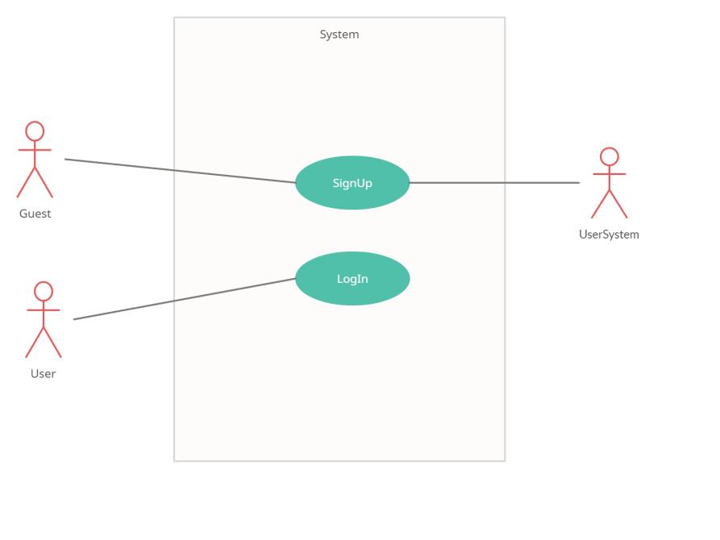

Figure 1: First use case model

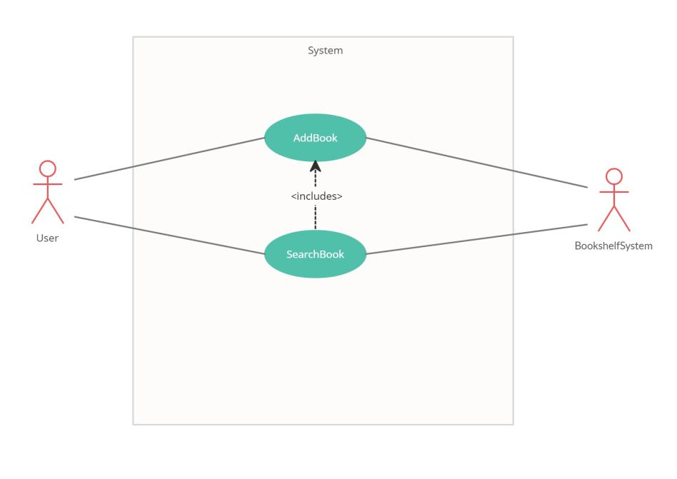

Figure 2: Second use case model 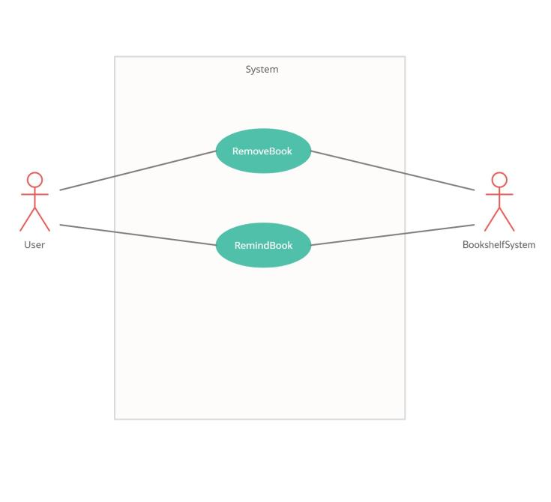

Figure 3: Third use case model

## 4.2-CLASS DIAGRAM:

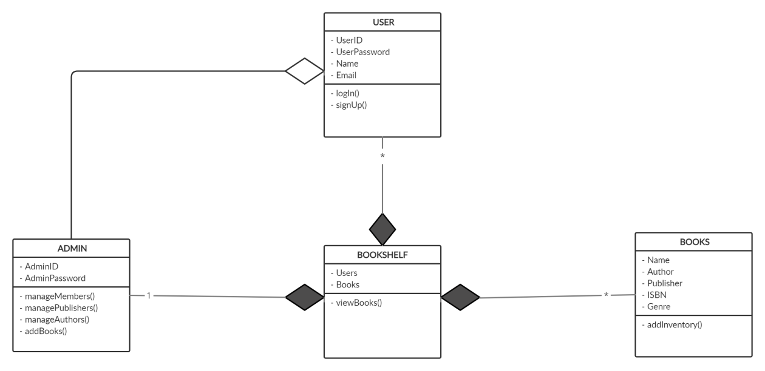

Figure 4: Class Diagram

## 4.3-SEQUENCE DIAGRAM:

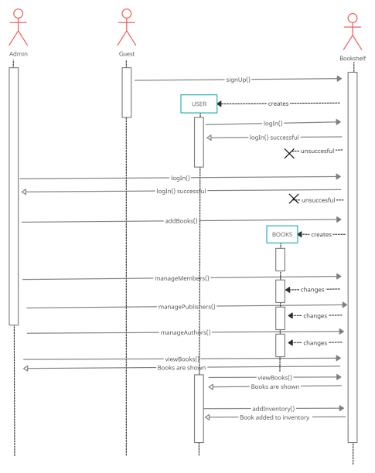

Figure 5 : Sequence Diagram

## 4.4-STATE DIAGRAM:

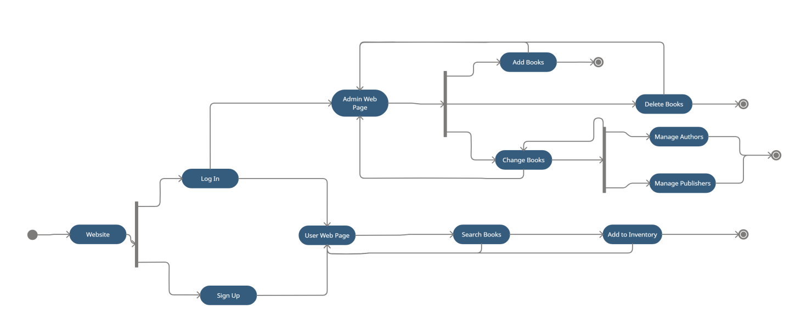

Figure 6: State Diagram

# **5-How to Run Sprint?**

## 5.1- First Sprint

## We made Specific Requirements and diagrams in the first Sprint. The Planning phase is started with User stories. Two week is to be spent on that, after which is conducted a meeting with customers, Scrum Master and Programmers for the scheduling of releases with everyone's agreement. The more important part after that is the iteration planning based on the User stories.

## We organized our meeting to design the web site the customer asked us. As a result of the meeting, we identified the needs and distribution of tasks in order to make a short demo of the website requested by the customer.

## 5.2-Second Sprint

We started coding after the first sprint, first we created a user interface.

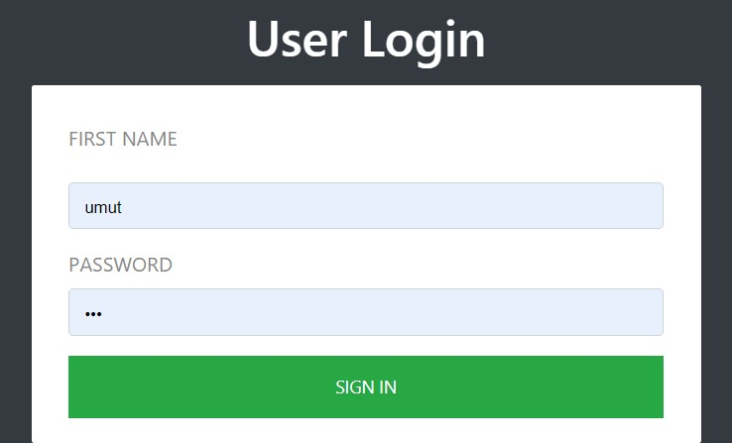

Figure 7 : Login page (User login)

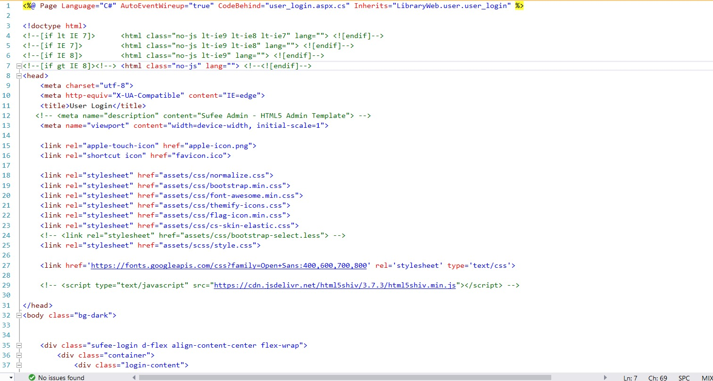

Figure 8: User registration and login creation codes

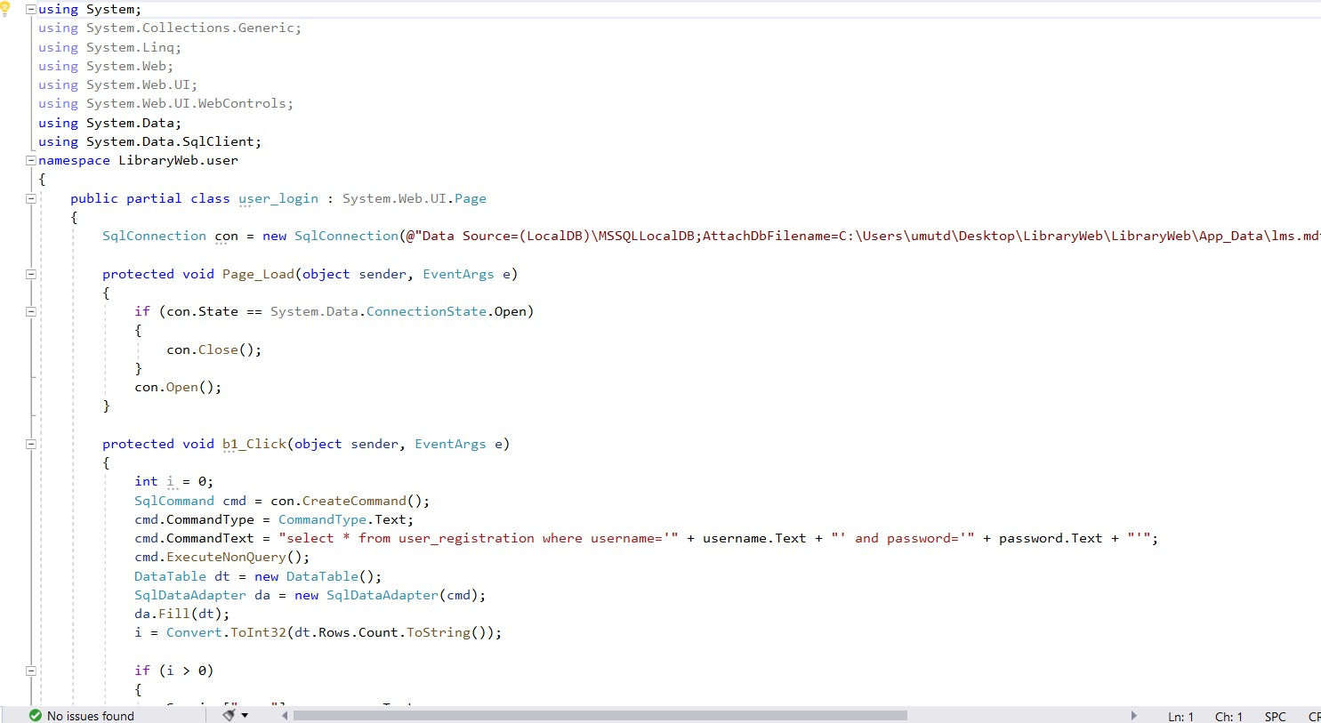

Figure 9: New user creation and registration codes

We creating homepage and linking to pages.

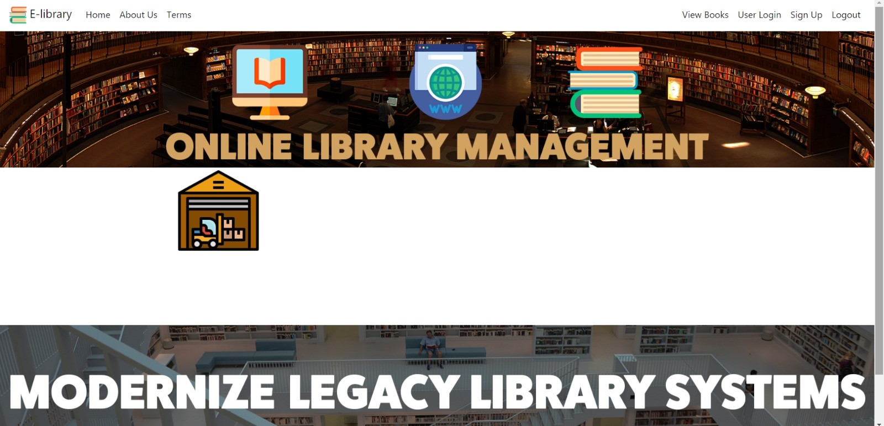

Figure 10: Home web page

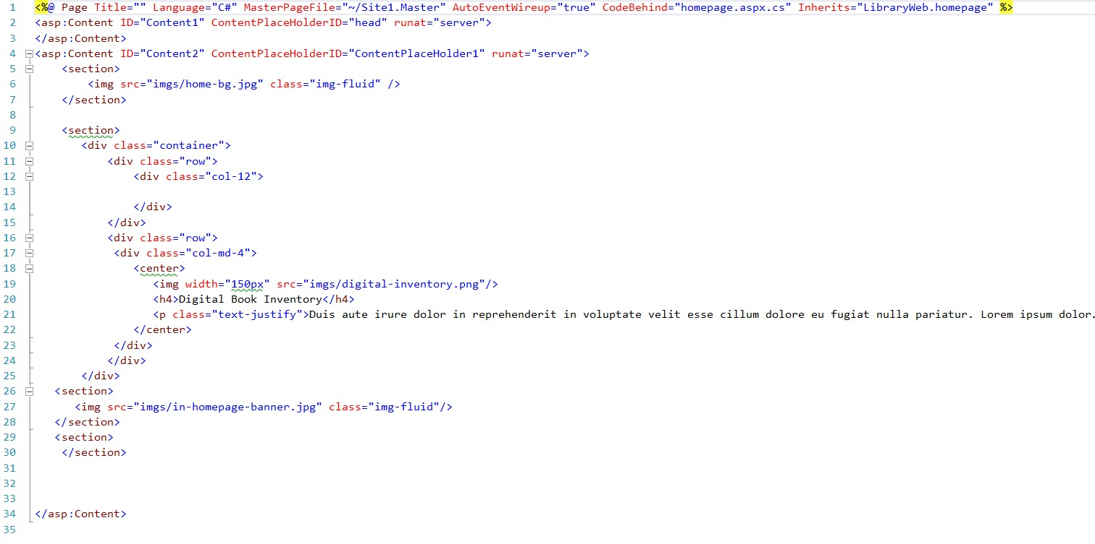

Figure 11 : Codes of the main web page

## 5.3-Third Sprint

Database was the most difficult part of this project for us. because we had very little experience with this issue. We have watched many videos and solved them for a long time by getting help from the databases made before.

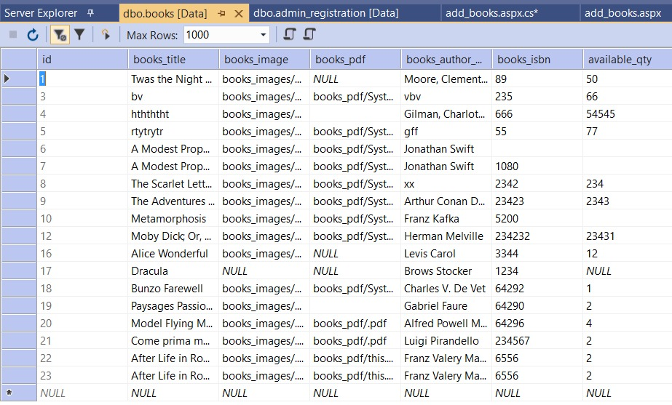

Figure 12: Books database

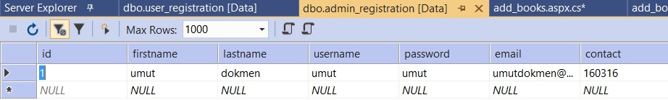

Figure 13: Book database for the users

We added various books and made them appear in the books section. At the same time, we tried to add the books to our own interface using the user interface.

## 5.4-Fourth Sprint

At this stage, we checked the things we did. We completed what we lacked. We tried to improve the interface. We improved the parts we used in the project such as database, photographs and books.

## 5.5- Fifth Sprint

We ran the last sprint of our project. We tried to prepare our code as best we could. If the user is not registered, he / she can register. Registered users can login. The user can see the photo of the books, authors, contents and the numbers required for the registration of the book.

# **6-ERRORS**

## 6.1- Syntax Error

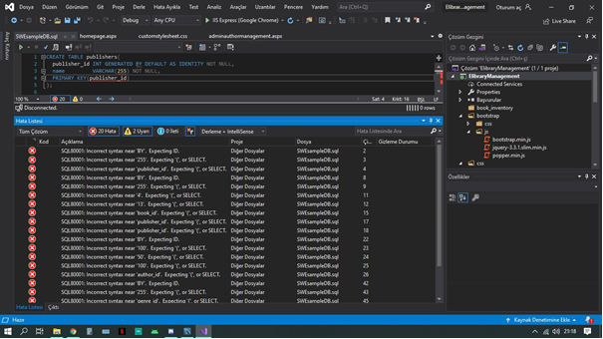

Figure 14: Syntax Errors

## 6.2- Token Error

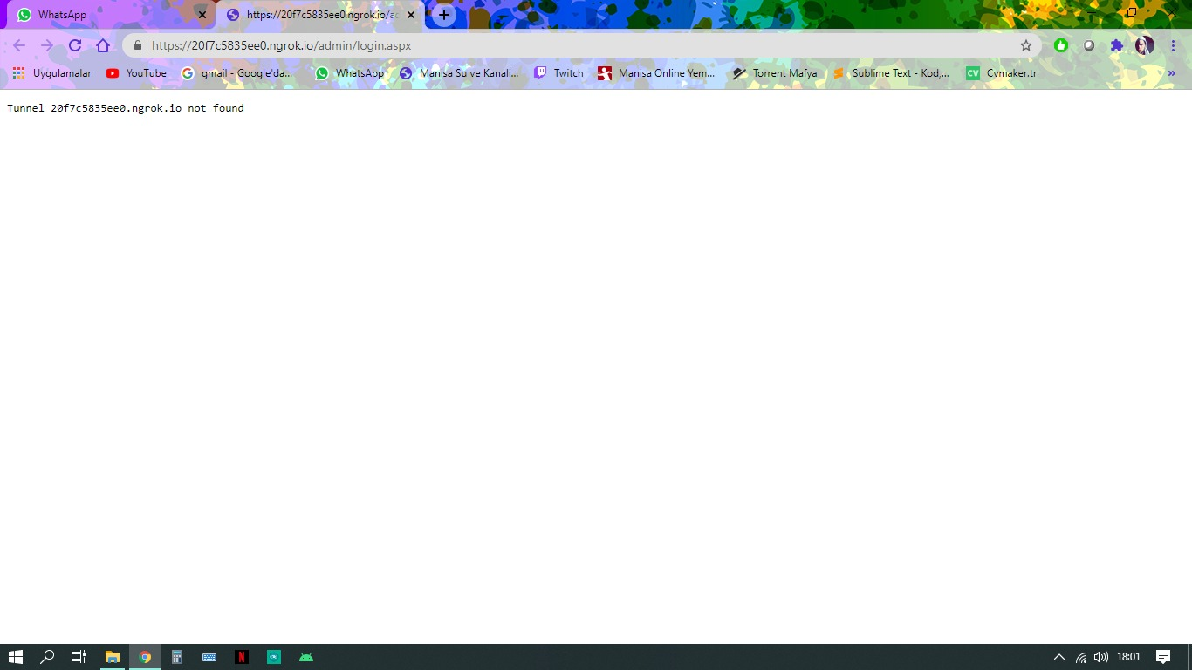

Figure 15: Token Errors

## 6.3- Source Error

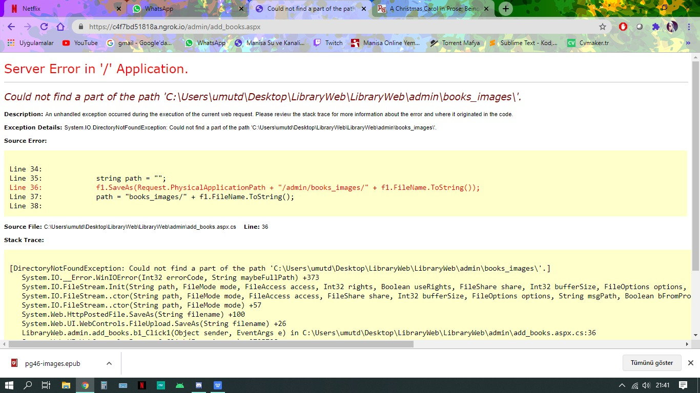

Figure 16:Source error

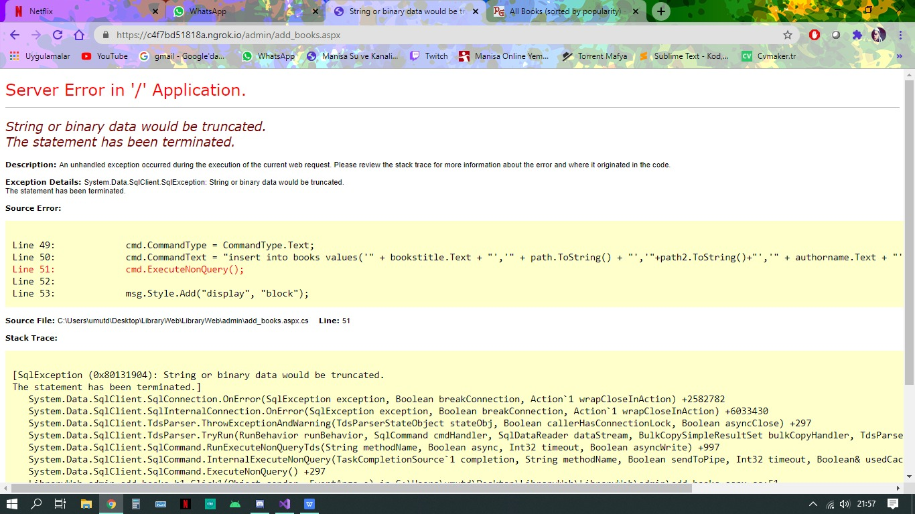

Figure 17: Source error

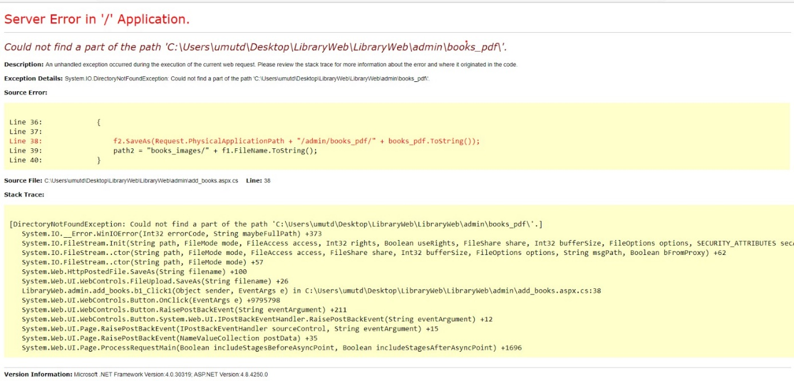

Figure18: Source error

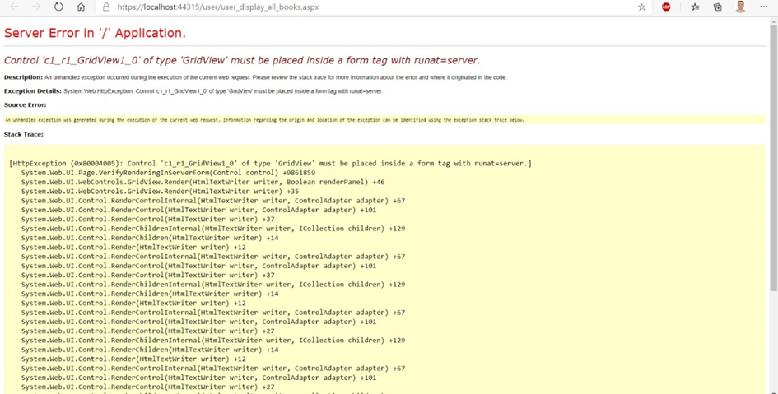

Figure 19:Source error

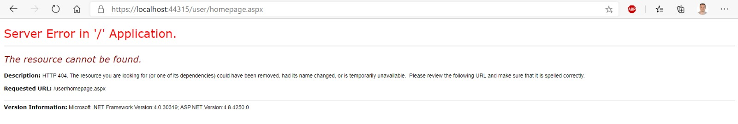

Figure 20: Source error

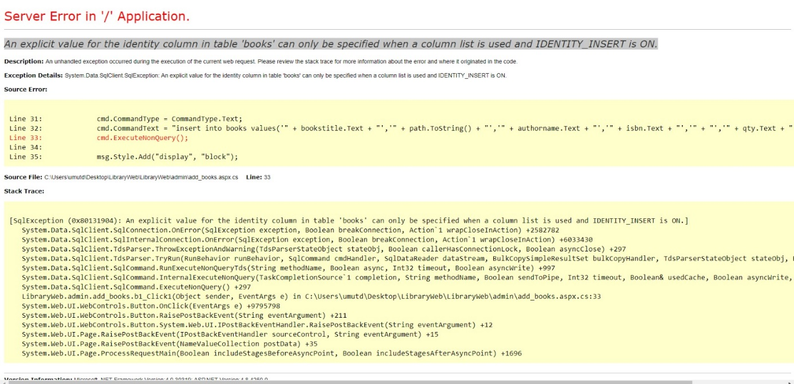

Figure 21: Source error

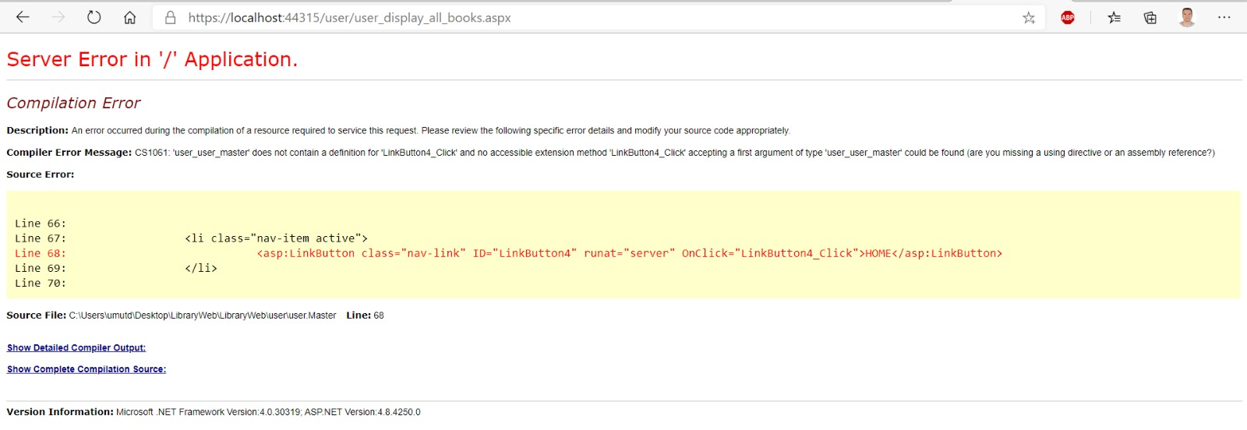

Figure 22: Source error

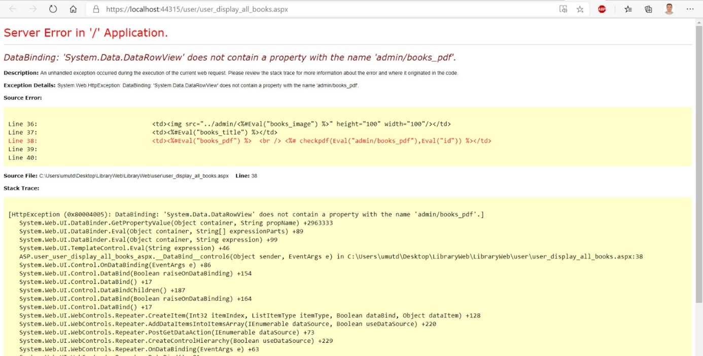

Figure 23:Source error

## 6.4- Compilation Error

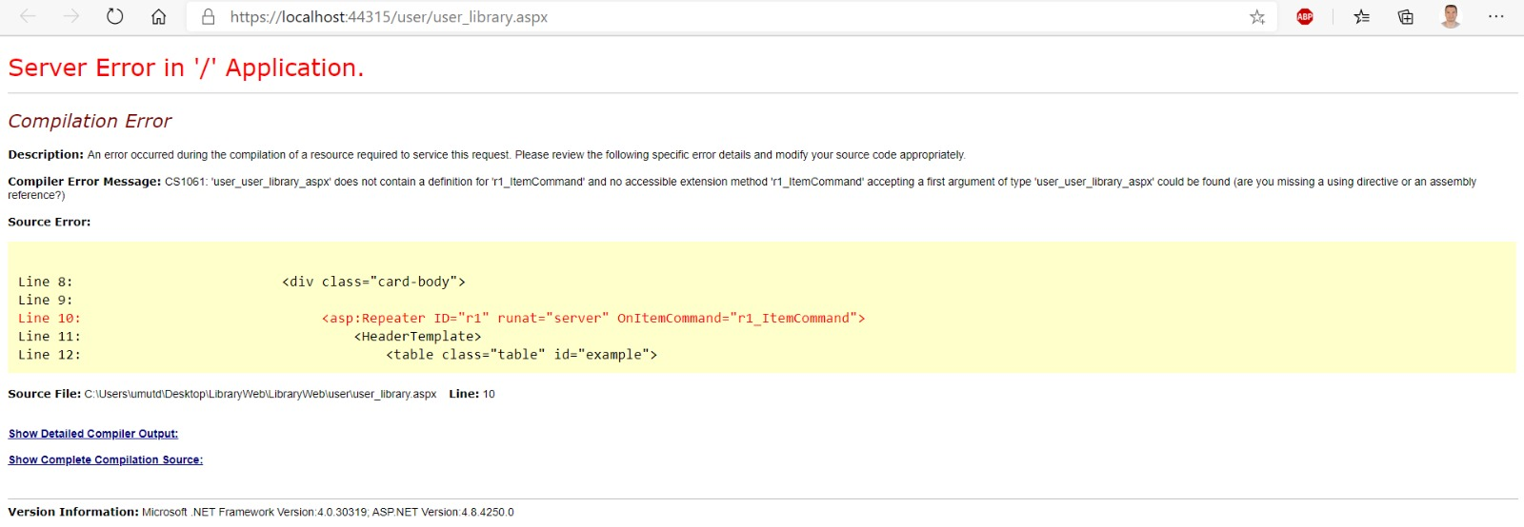

Figure 24:Compilation error

## 6.4- HTTP Error

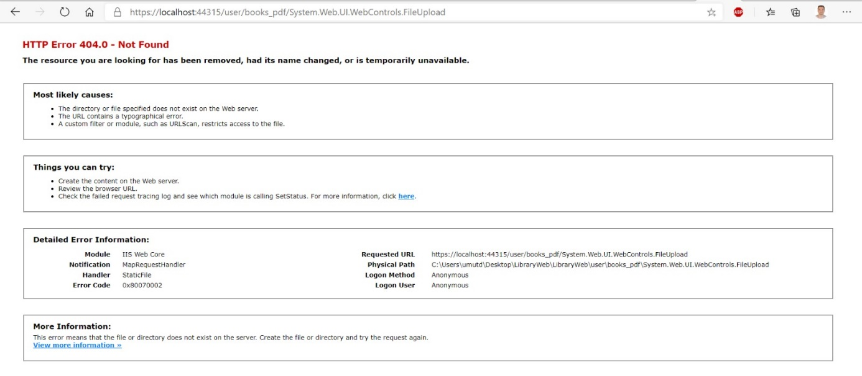

Figure 25:http error

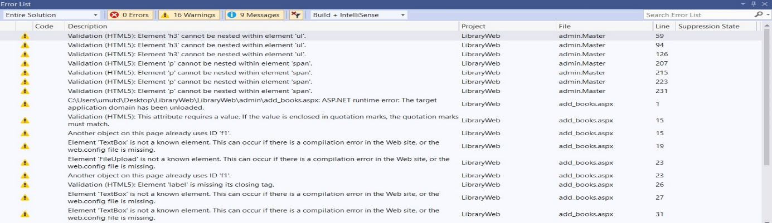

Figure 26: http error